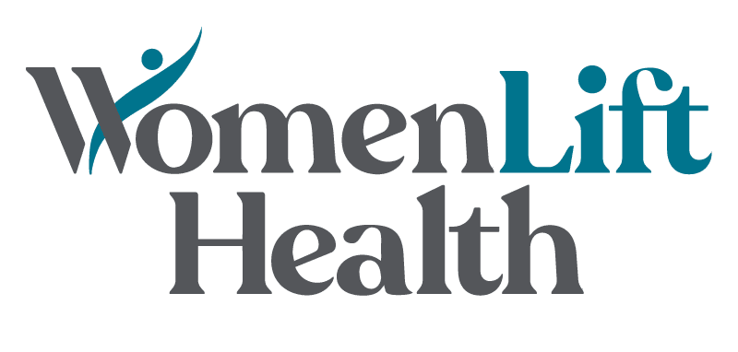
U.S. Leadership Journey 2022
Application & Program FAQ

Application Questions:

- How do I apply?
Please review all components of the application here and apply by November 19, 2021. In addition to basic personal information, you will be asked to submit your Leadership Project idea and responses to a set of Leadership Snapshot questions. You will also be asked to submit your resume and a letter of recommendation that speaks to your abilities and experience.

- When will I find out if I’ve been accepted?
After a period of application review, we will notify applicants about their acceptance, waitlist, or rejection status in late January 2022.

- Why am I being asked to submit a letter of recommendation from my supervisor?
The purpose of the letter from your supervisor is to garner internal support and space for you to take on this journey and to “sow a seed” with organizational leaders so they begin noticing the environment in which their women leaders work and potentially, begin thinking about ways to make it more gender-equal.

However, if you are unable to obtain a letter of recommendation from your direct supervisor, you may submit a letter written by a senior leader at your current organization or a leader in the global health community who has experience working with you.

- Can I apply if I previously applied and didn’t get accepted?
Yes, but we recommend that you apply again only if you believe you have significantly added to and enriched your professional experience since your last application.

- Is there a cost if I’m selected?
The Leadership Journey is fully funded. All the leadership resources provided during the year as well as travel, lodging and food expenses for the in-person engagements are covered by WomenLift Health. However, the initiative does not pay for your time. You will be expected to have access to a computer and internet to attend the virtual touchpoints.

Program Questions:

- What are the program expectations and what does the time commitment look like?
You are required to attend each virtual touchpoint and the in-person learning experiences* as detailed in the calendar, and to complete any intersession activities and the deliverables associated with the Leadership Project. The time commitment for the required Leadership Journey activities (all virtual touchpoints, intersession activities) ranges between 3-4.5 hours each month with the exception of the months of the in-person residencies. This estimate does not include the time required for the design, planning, and implementation phases of your Leadership Project, so please consider that in your decision to participate in the program.

You will also be asked to complete a “360-evaluation” and leadership style assessments, inform your understanding of your leadership strengths and growth areas. The 360-evaluation will involve soliciting feedback from your boss, peers, direct reports, and others.

As our approach involves human-centered design, we will ask you to evaluate the experience and contribute ideas for how to enhance the Leadership Journey for future cohorts.

- What are Learning, Mentoring, and Coaching Touchpoints?
Learning Touchpoints: Learning Touchpoints are facilitated, virtual group sessions. Cohort members explore leadership frameworks, research & tools in highly interactive learning touchpoints and workshop-style sessions focused on dynamic practice. The touchpoints focus on personal & professional growth, current events in the global health sector, as well as their Leadership Projects.

Mentoring Touchpoints: As part of the Leadership Journey, WomenLift Health identifies senior-level mentors from different backgrounds, health sectors, and disciplines to serve as mentors to the cohort. Mentoring groups, comprised of several cohort members and one mentor, are grouped based on complementary backgrounds and professional trajectory. Cohort members will be able to rely on their mentor to serve as a technical and career resource during the Journey.

Coaching Touchpoints: Cohort members will be paired with a Coach who works one-on-one with them to build on their strengths and address areas for growth. Leadership style assessments, including a “360-degree evaluation,” will inform these conversations and enhance each participant’s understanding of their own leadership skills.

- What are the Leadership Immersion and Leadership Lift-Off events?
At the core of the journey are also two in-residence experiences*: the Leadership Immersion (early-Journey) and the Lift-Off event (end of Journey).

The ‘Leadership Immersion’ is a 3-day experiential convening that takes place a few months into the Journey, where through dynamic discussions, presentations, and hands-on exercises, cohort members enhance their skills, apply them to real-world examples, and reflect on lessons learned. A series of powerful conversations will complement the instruction, featuring eminent figures in global health who have led transformational change, and who are able to impart practical knowledge that can be immediately applied to varied career and life situations.

At the end of the year-long Journey, the 2-day ‘Leadership Lift-Off’ event celebrates the cohort’s growth as they ‘lift off’ to a new phase of their leadership. This week provides time for the cohort to reflect on their leadership evolution through the course of the year and to present their leadership projects to their peers as well as other global health audiences.

- What does a Leadership Project entail?
The Leadership Project, required of every cohort member, is an opportunity for each member to design and lead an effort that taps into each woman’s expertise, network, passion, and creativity. The cohort will be asked to refine their project idea and develop a theory of change in the first 3 months of the Journey, devise an implementation plan and stakeholder map in the following 3-4 months, and start implementing their plan in the last 5-6 months. At the Lift-Off event, the cohort will present a summary of their project’s development and implementation, as well as any early outcomes.

The implementation of your Leadership Project does not have to be complete by the Lift-Off event and will likely continue beyond the 12-month Journey.

- What kinds of ideas would be appropriate for a Leadership Project?
There are only 4 rules for the Leadership Project:
- It should focus on improving outcomes at the intersection of health and gender equality, or take a gendered lens on a global health issue
- It should leverage your leadership skills
- It should be within your scope of control or influence, but also stretch you beyond your day-to-day work requirements
- You should be passionate about it

Your Leadership Project could accomplish one or more of the following, but is not limited to:
- Answering a research question
- Promoting health or gender education in a particular group
- Developing a new or better technology
- Innovating a better way to collect/analyze/use health/gender data
- Improving a gender or health-related process/system in your organization
- Empowering or enabling women in your community or organization to be successful
- Incorporating a gendered lens into a policy, practice or research project where it was absent

See examples of Leadership Projects from the 2020 Cohort here.

This is your year to use your leadership skills and the peer, mentoring, coaching support available to you to bring to life a special idea that improves health and gender equality.

- How will this help me to connect with other women leaders in global health?
Throughout the Journey, we’ll build a community where fellow cohort members collaborate and learn from each other, one that will continue after the Journey concludes. We intend to keep alumni engaged and wish to continue learning with and from you long after the completion of your Leadership Journey.

Our goal is to create a robust network of alumni at the global, regional, and local levels who continue to support each other and new cohort members, for example as mentors, and to also advocate for women’s leadership locally and at large. To facilitate networking among the cohort community and amplify your voice, we will heavily leverage our digital platform (website, social media platforms, etc.). You will become part of the WomenLift Health family. Our resources will be yours and we will always value and nurture this relationship.

- How can I balance this leadership opportunity with my already busy professional and personal life?
This 12-month Journey is designed for the working woman. We realize that work-life harmony is a key challenge holding many women back from climbing up the ladder of success, and we do not want to add further burden to your personal and professional life. We promise to work with you and take an integrative approach towards incorporating your personal needs into this journey.

*Covid Caveats: Please note that due to uncertainties caused by Covid-19, the programming and calendar, including the in-person events, may need to be converted to an all-virtual format.

